# Advanced Data Visualization - Lab #5

|  |  |
| --- | --- |
| Provided file(s): | * LAB05.docx * pizza.csv * data_science_colleges.csv * LD-Case-Counts-by-County-00-17 |
| Submission file(s): | * LAB05.docx * LAB05_1.twb * LAB05_2.twb * LAB05_3.twb |

Work in groups. Submit your file(s) through Blackboard. Only one person may submit for a group. Only the last submission will be marked.

## **Part I: Pie chart**

Open **Tableau Desktop**.

* 1. Choose **Open >> File** and select “pizza.csv”.
  2. Create the following bar graph.

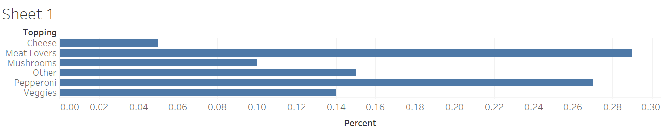

* 1. On the **Show Me** card, choose **pie chart**. Note the **Marks** card.
  2. Increase the size by holding down **Ctrl+Shift** (or **Command+Shift** on a Mac) and pressing the **B** key several times.
  3. Change the title to “What's Your Favorite Pizza Topping?” and paste the image of the pie chart here:

## **Part II: Donut chart**

1. Create a new **Worksheet** and repeat the above steps to make the pie chart.
2. Drag “Number of Records” measure to the **Rows** shelf and right-click its pill. Select **Measure (Sum) >> Minimum**.
3. Repeat the previous step, so you have two pie charts.
4. Right-click the second instance of **MIN(Number of Records)** (the pill) and select **Dual Axis**. You should something like this chart:

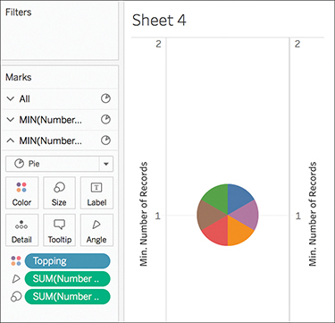

1. Now, we have two pie charts on top of each other. We want to make one smaller and white in the center of the other one, to make it look like a donut chart. To do this, go to the **Marks** card and click the second instance of **MIN(Number of Records)**.
2. Remove any pills from the **Color** and **Size** marks. (Right click and choose **Remove**). You should see a gray circle.
3. Click **Color** and choose **White**. Your chart disappears into the background.

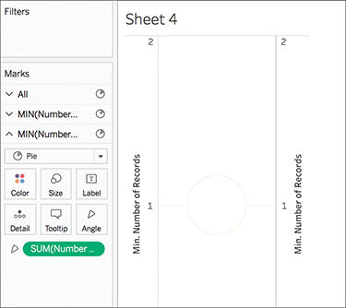

1. Select Size and drag the slider to the left. Your donut should appear.

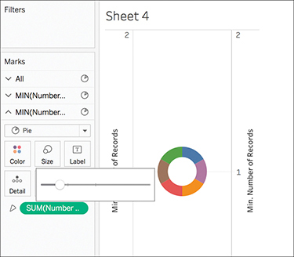

1. Click on the axis, and uncheck **Show header**.
2. On the **Marks** card, go to the first instance of **MIN(Number of Records)**. Drag and drop the **SUM(Percent)** pill onto **Label** card. You should see the numbers around the donut chart.
3. Right-click the pill created and click **Quick Table Calculations >> Percent of Total**.

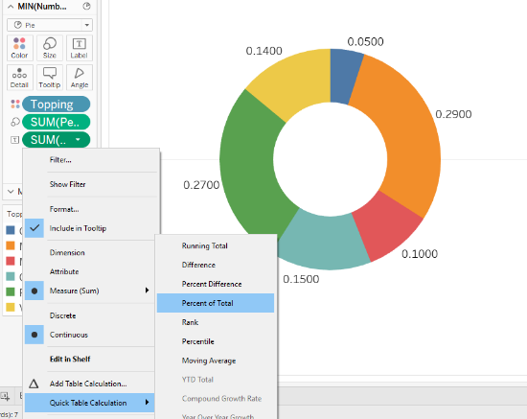

1. The percentages will appear outside the donut. Paste the image here:

1. To move the labels inside the donut, we need to use the second inside pie chart (the white one!). Remove the outside labels first by right-clicking the label pill and choosing **Remove**.
2. On the **Marks** card, go to the second instance of **MIN(Number of Records)**. Drag **Toppings** onto the **Label** card. Then drag **Percent** onto the **Label** card. Change the values to percentages, as you did above. You may wish to re-adjust the sizes of the two pie charts at this point, to suit your tastes.
3. Add a title and paste the image here:

1. Save your tableau file as **LAB05_1.twb** and submit.

## **Part III: Overview of Maps in Tableau**

Watch the getting started video available at <https://www.tableau.com/solutions/maps>, as an overview of maps in Tableau. In this workshop, you will create some basic maps.

## **Part IV: Proportional Symbol Map**

Open **Tableau Desktop**.

1. Choose **Open >> Text File** and select “data-science-colleges.csv” [Source: <https://github.com/ryanswanstrom/awesome-datascience-colleges>]

Which data columns have the globe (geo-data) symbol? 

1. Go to **Worksheet**. Note that there are two measures generated: **Latitude** and **Longitude**. These were not in the data source itself, but were automatically by Tableau from the geo-data available in the source. Double-click each of these two measures to build a map. Note that **Longitude** will be located on the **Columns** card and **Latitude** will be located on the **Rows** card.
2. Note that under **Dimensions**, there is a hierarchy of geo-data created: **Country**, **State**, **City**. To see data at the city level, drag **City** from this hierarchy on to the **Detail** card. You will see data points on the map, for the cities which have data science programs.
3. To get a more compact view, right-click the data points in **Hawaii**, **Spain** and **South Korea**, and choose **Exclude**. Also, click on the “47 unknown” message on the lower right side of the Worksheet and choose **Filter Data** to exclude the unknown locations.
4. To use size to encode the number of programs in each city, drag the measure with …*(Count)* at the end of its name (it is a count of the number of records) onto the **Size** card. Now you have a **Proportional Symbol Map**.
5. Drag the **Degree** dimension onto the **Color** card. On the legend, right-click **A** (**Associate**) and **C** (**Certificate**) and choose **Exclude**. Now your map is color-coding the Bachelor, Masters, and Doctorate programs.
6. Add your group number to the title and paste your graph here:

1. Save your tableau file as **Lab05_2.twb** and submit.

## **Part V: Geographic Roles**

Open **Tableau Desktop**.

1. A screenshot of a computer

   AI-generated content may be incorrect.**Open >> File** and select “LD-Case-Counts-by-County-00-17.csv” [Lyme Disease dataset, source: <https://www.cdc.gov/lyme/resources/LD-Case-Counts-by-County-00-17.csv>]

1. Note on the **Data Source** tab, that Tableau did not automatically recogize the county and state names as geo-data. To do this manually, click the **Abc** symbol next to **Ctyname**, then choose **Geographic Role >> County**. (Note that **Cty** here stands for “County”, *not* “City” or “Country”.)
2. Similarly, for **Stname**, choose **Geographic Role >> State/ Province**.
3. A screenshot of a computer

   AI-generated content may be incorrect.Go to the Worksheet. Note that a hierarchy is not created automatically. To create the hierarchy, right-click **Stname** under **Dimensions**, then choose **Hierarchy >> Create hierarchy** (as shown in the figure) and name it “Location Hierarchy”.
4. Drag and drop **Ctyname** on to **Location Hierarchy**, right underneath **Stname** (since **State** is a broader category than **County**).

1. Continue to Part VI with the same dataset.

## **Part VI: Choropleth Map**

A *Choropleth* is a filled map suitable for showing ratio or aggregated data. After preparing the data in Part V, continue with the following steps.

1. Double-click **Stname**. This is another way (similar to double-clicking **Latitude** and **Longitude**) to create the map, with one data point per state.
2. If there are few if any dots on your map, your Tableau is probably localized to the wrong region. Click the “51 unknown” (or similar) error at the bottom right, if there is one. Then click **Edit Locations**, and choose **United States** under Country/Region if it is not already selected. Click **OK**. If there is still an “unknown” error on the bottom right, click it and filter the remaining unknown data.
3. To create a more compact map, exclude the **Hawaii** and **Alaska** data points. Note the change in **Filters** card.
4. Drag and drop **Ctyname** onto the **Detail** card. Filter any unknown data and note the change in **Filters** card.
5. To transfrom the symbol map to a filled map, drag the **Cases2017** measure onto the **Color** card. Note that the **SUM** of lyme incidents is color-coded.
6. Using the **Color** card, choose a more alarming color palette, such as **Red** or **Orange**.
7. Also using the Color card, choose **None** for **Border Effect**.
8. Drag and drop **Cases2017** onto the **Filters** card. Choose **Sum** and click **Next**. Change the lowest number from 0 to 1 and click **OK**. Now, only counties with at least one case of lyme disease are shown.
9. Change the title to “Total number of lyme disease incidents”, add your group number, and paste an image of your heat map here:

1. Double-click on **SUM([Cases2017])** and edit it to **SUM([CASES2017] – [Cases2016])**, to show the increase in the number of incidents in 2017 compared to 2016.

1. In the **Color** card, choose **Edit Colors** and check off **Reversed** so red is used for the positive numbers (increasing incidents).
2. From the menu, choose **Map >> Background Layers… >> Style >> Normal**.
3. Change the title to “Increase in the number of Lyme incidents in 2017 compared to 2016”, with your group number added, and paste here:

1. Save your tableau file as **Lab05_3.twb** and submit.